Project 2-4: Price Comparison

Objectives
Use concepts from Chapter 1 & 2 to complete Project 2-4

Description
Create a program that compares the unit prices for two sizes of laundry detergent sold at a grocery store.

Requirements
- The expected output image provides the format for the program output
- The price of each laundry detergent size is entered by the user.
- The formula for calculating price per ounce is:
price per ounce = price / ounces
- The program should round the results to a maximum of two decimal places
- Assume the user will enter valid data

Expected Output
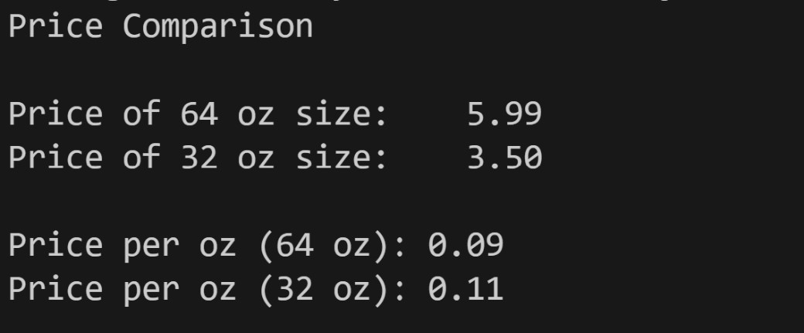

Grading Criteria
File naming convention | 5
Comments (Minimum file header comments and interior code) | 15
Use of input() function | 10
Use of F-String and/or string concatenation | 10
Descriptive variable names | 20
Arithmetic calculations correct | 10
Output format | 30
Code does not compile | -50
Total | 100

